FOR IMMEDIATE RELEASE
Date: November 25, 2023
For more information,
Contact: Carol Green, VP/Operations and Communications
Email: carolgreen2@mac.com
Mobile: (303) 886-6531
Middle East Expert to Present Special Webinar on Middle East Conflict
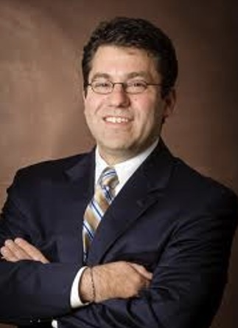
Steven A. Cook
NAPLES, FL – Steven A. Cook, an expert on international affairs and diplomacy in the Middle East, will present a special webinar titled “This War Won’t Solve the Israel-Palestine Conflict” for members of the Naples Council on World Affairs (NCWA) on Monday, December 4.
Cook, Ph.D., is Eni Enrico Mattei Senior Fellow of Middle East and Africa Studies at the Council on Foreign Relations. The webinar will be at 4:00 pm on December 4.
“At moments of crisis in the Middle East, many always expect the Israelis and Palestinians to walk up to the abyss, look over, and pull back for the sake of a better future,” Cook said in announcing the webinar. “Instead, they metaphorically join hands and jump together. Although the stakes in the current war for Israelis and Palestinians alike are quite high, they are not likely to be more forthcoming regarding peace than before the conflict. Quite the opposite, the Israelis and Palestinians are now farther away from a two-state solution than any time in the last three decades.“
Membership enrollment in NCWA is open for the season at www.ncwa-fl.org. NCWA is a non-profit, non-partisan membership organization whose mission is to educate, inspire and engage our community in international affairs and critical global issues.
NCWA has 1,600+ members from the Greater Naples area and is affiliated with the World Affairs Councils of America, which has 93 chapters in the U.S., 40 states and 90,000+ members.
###

